Website Utilization
Signing in
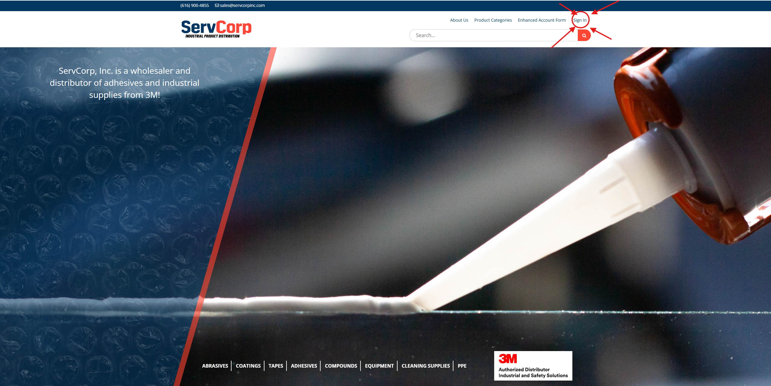
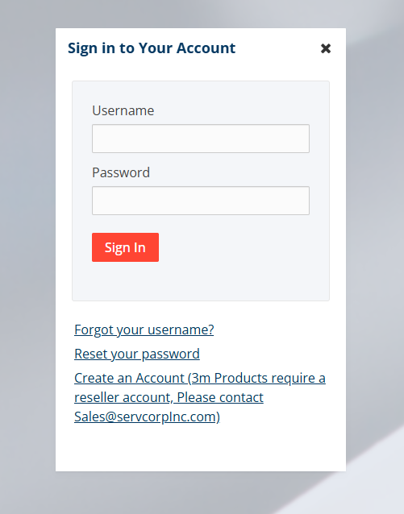
Enter in Username and Password

Product Categories
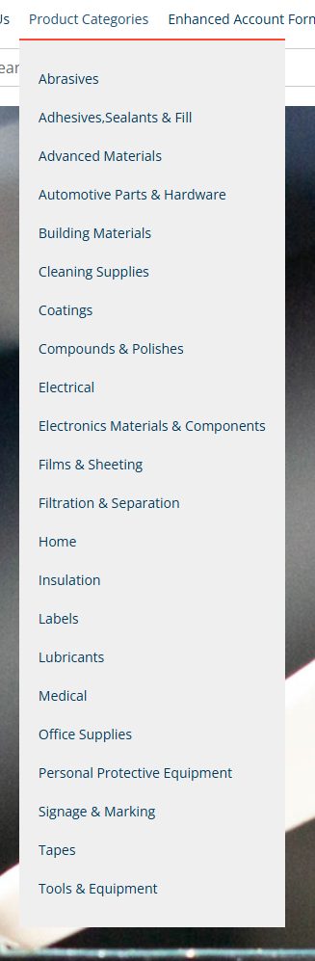

My Account
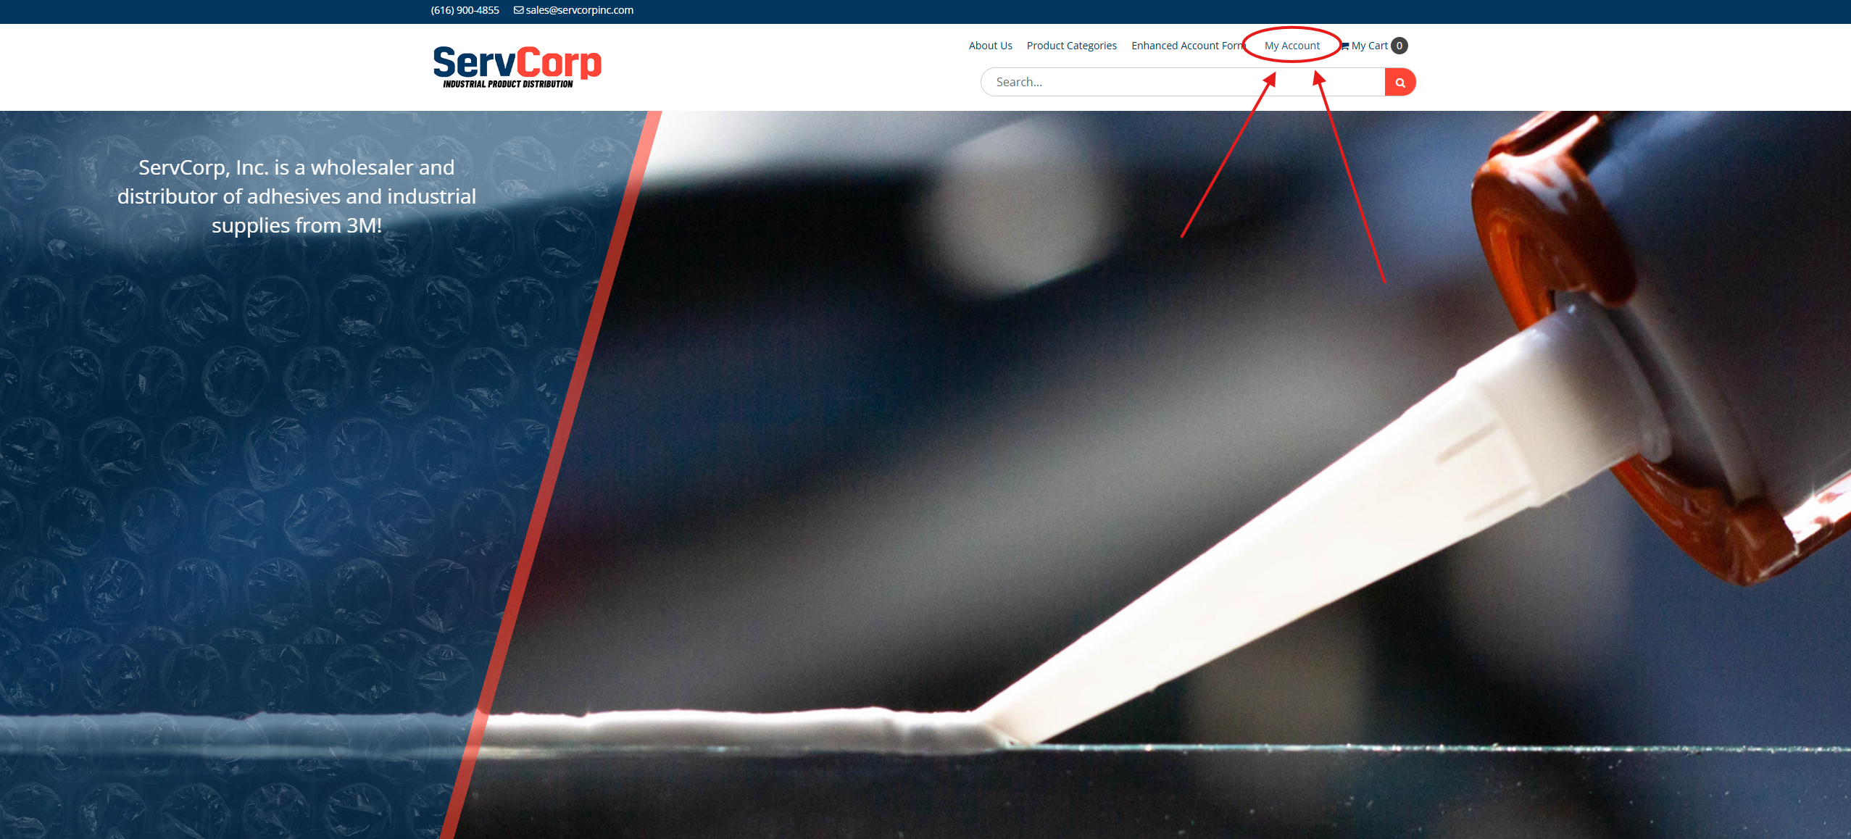
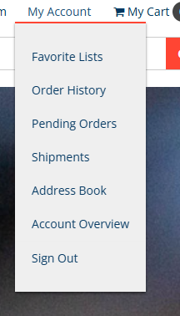
You can see your list of favorite products, order history, pending orders, shipments, managing your address book, and get and account overview

Favorite Lists
You can save a grouping of items to a favorite list. To do so, click the heart icon on the product
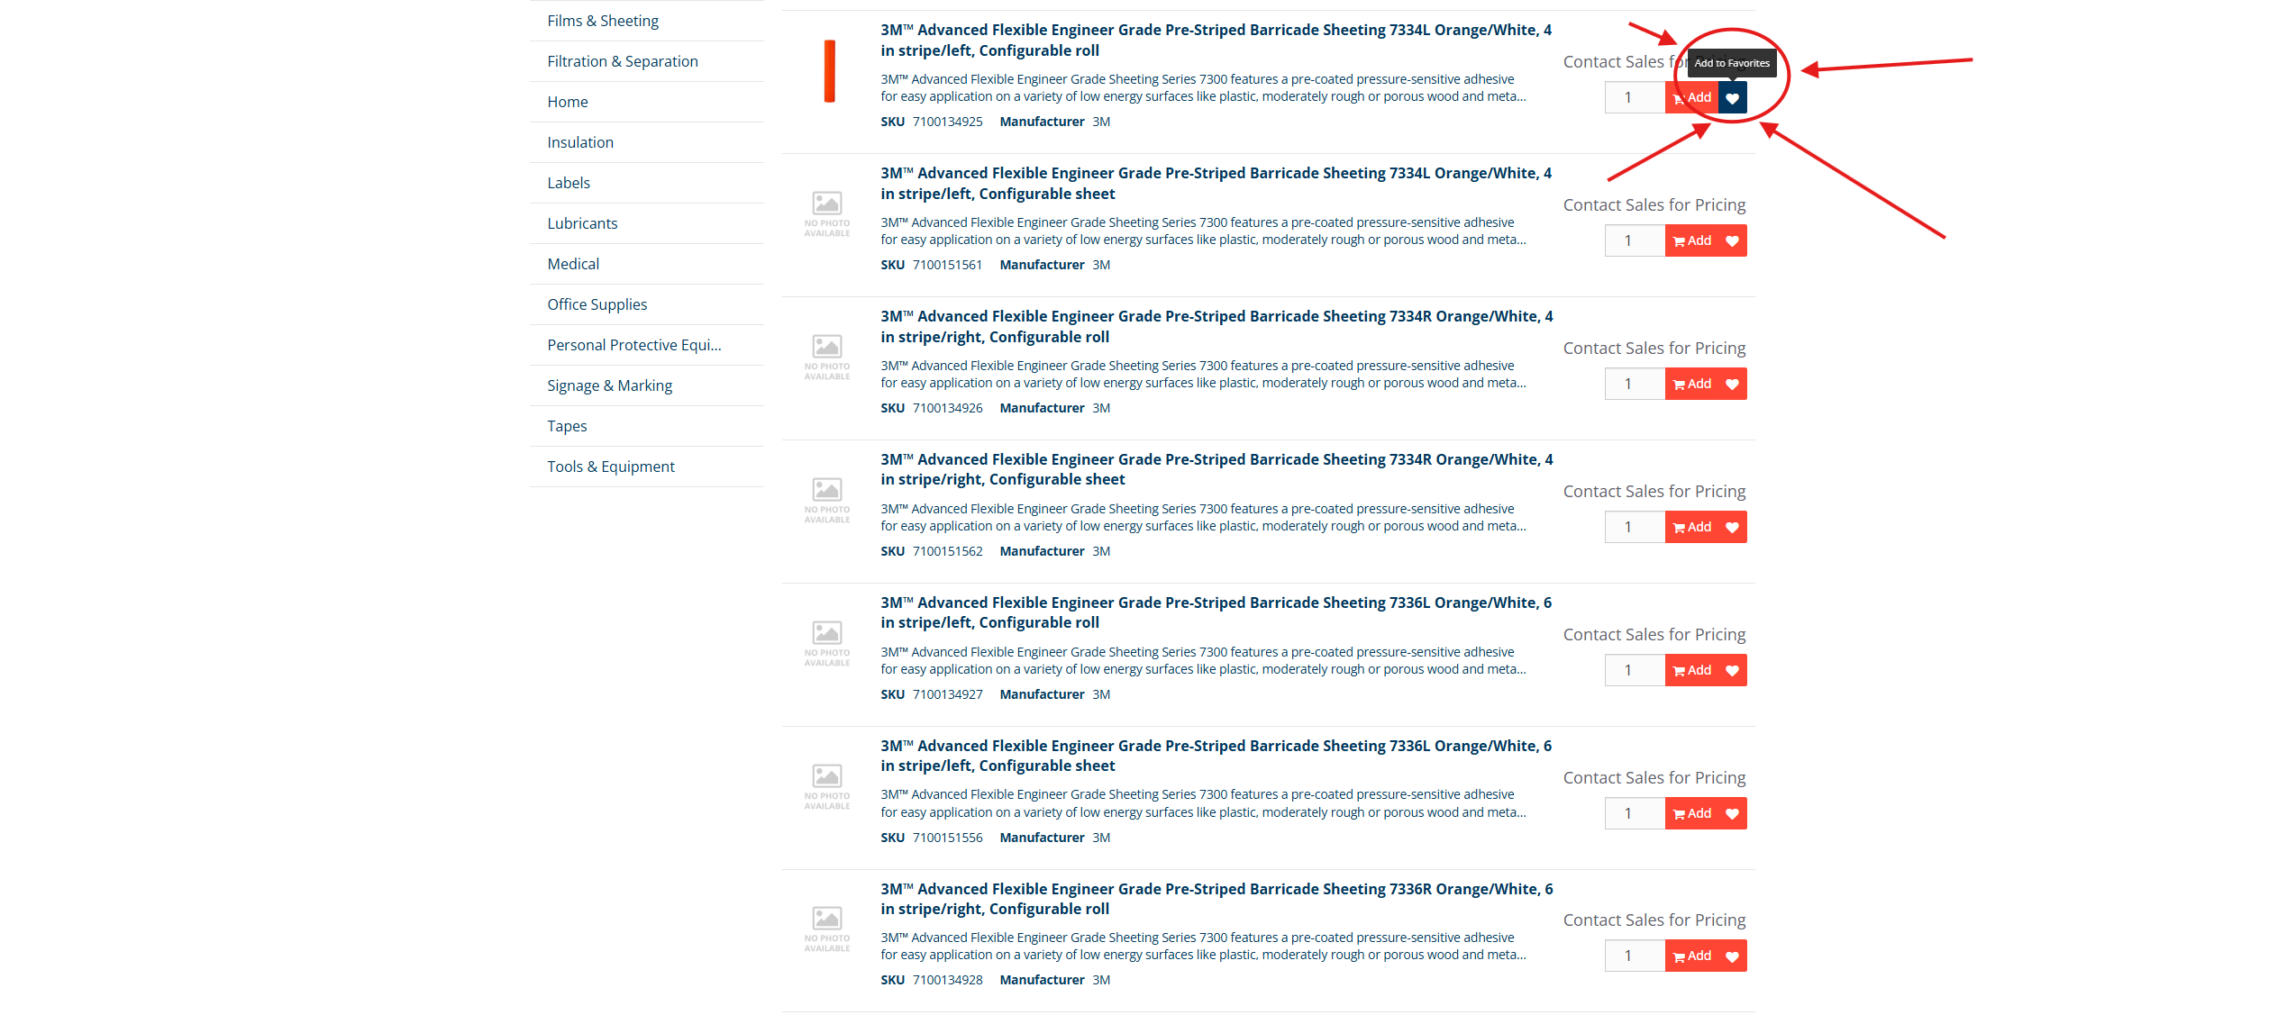
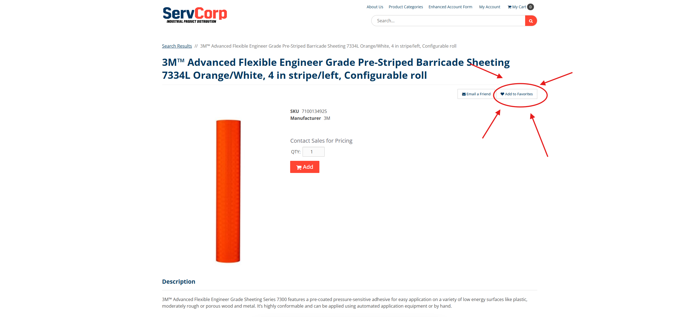
You then will be prompted to add this product to a list. From here you can pick from already created lists or make a new list.
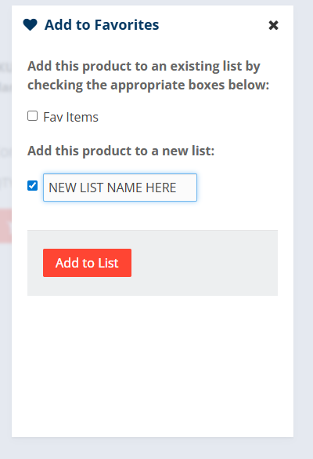
Too access these lists, click on my account, then click on “Favorite Lists” in the drop-down menu.
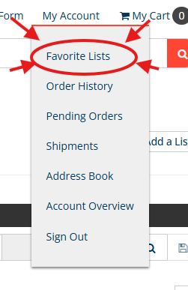
You then will see any lists created. From here you can add a list as well as edit or delete lists
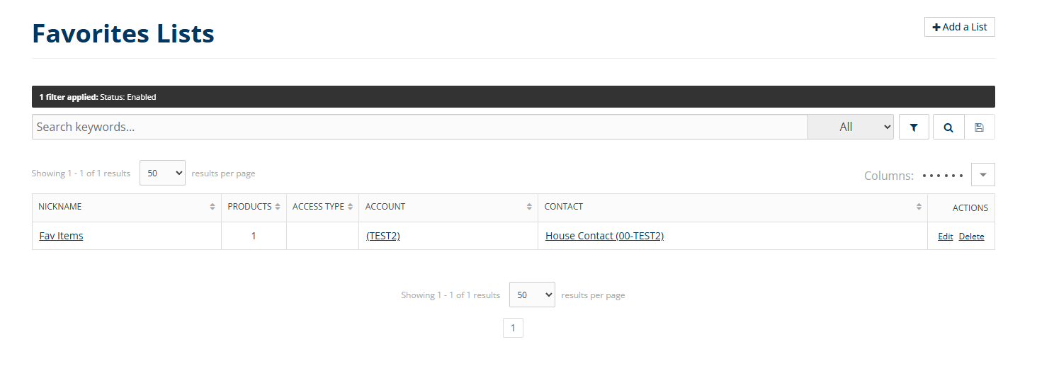

Order History
To see your order history, click “My Account”, then hit “Order history” from the drop-down menu
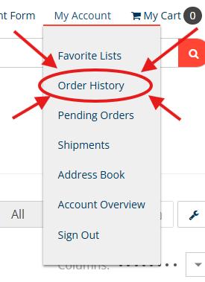
You will now see your order history. From here you can click into order # to see details on each individual order. You can also reorder from this screen by clicking “Re-Order” on the far-right hand side of the screen.
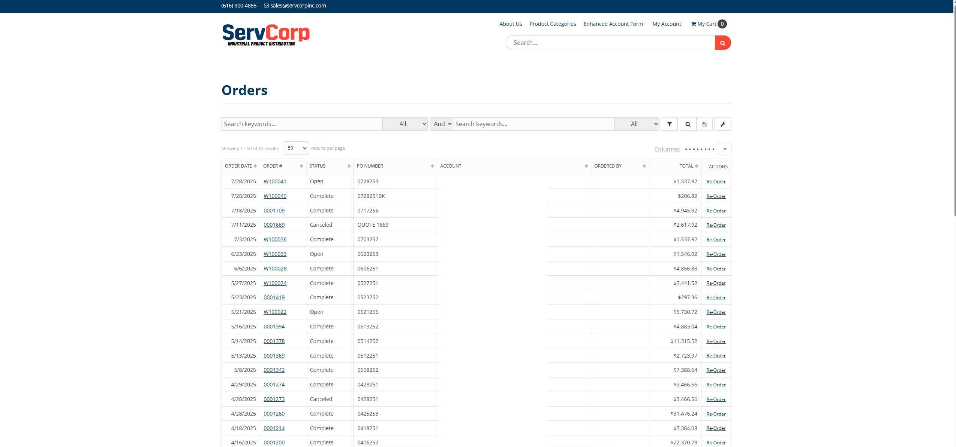

Shipments
Click on the shipments option in the drop-down menu
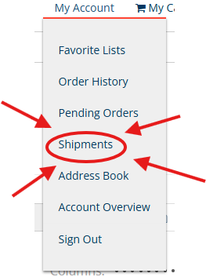
Here you can see tracking numbers associated with your orders. This will show you shipping dates, “shipping via”, and tracking # that is associated with orders.
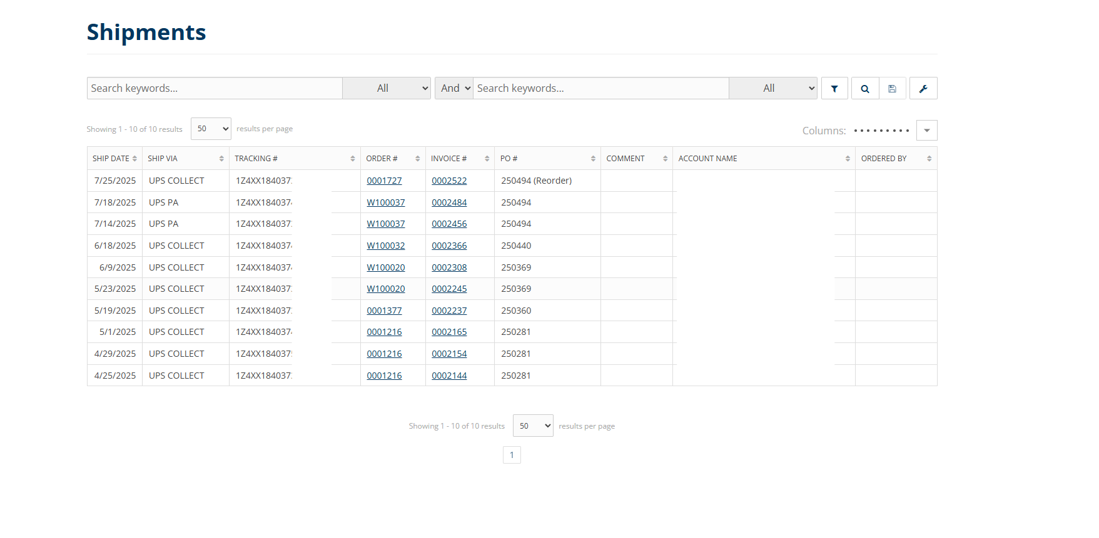

Address Book
This is where you manage the addresses associated with your orders.
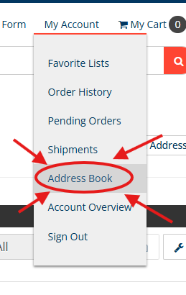

From this screen you will be able to see all addresses that are saved
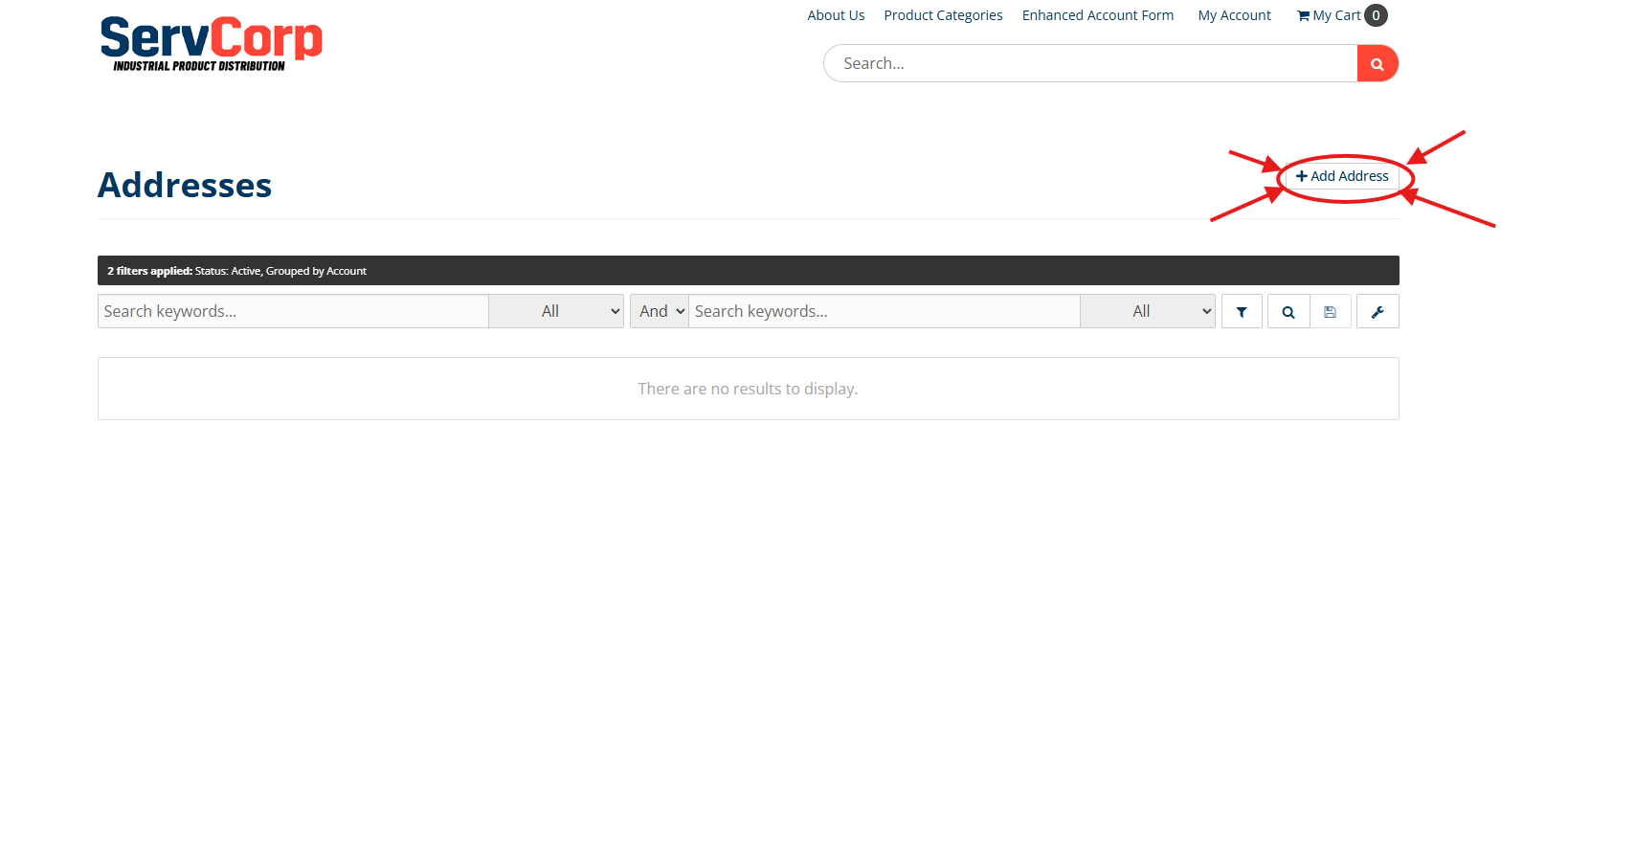
Click add address in the top right corner to create a new address.
Fill out the fields and create add address to get this added to your address book
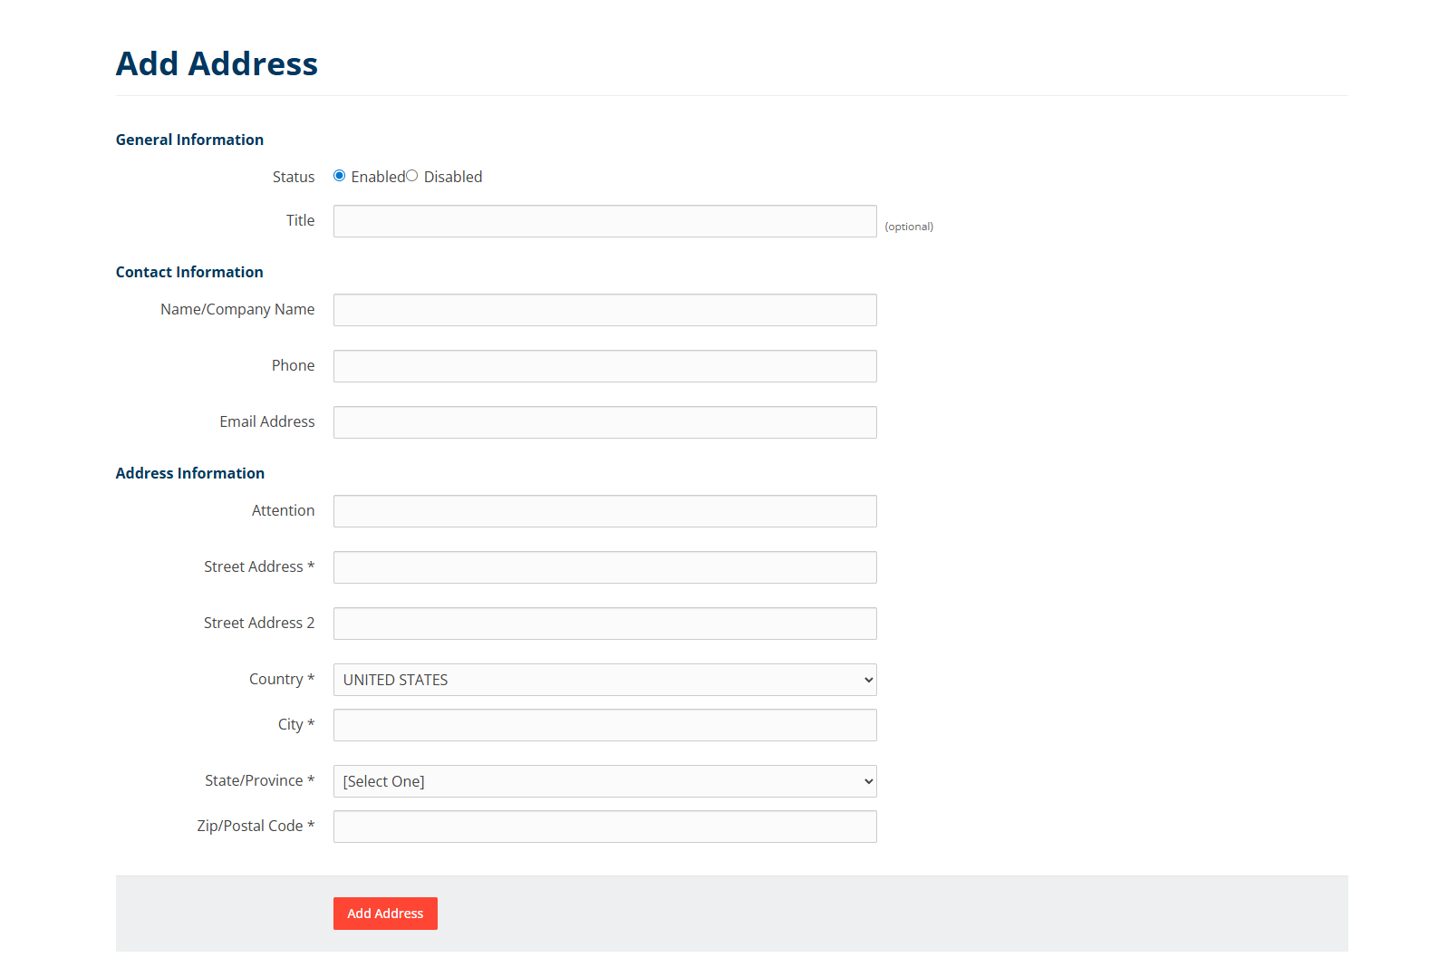

Account Overview
This menu provides many different pages of information. It can be accessed through “my account” drop down menu.
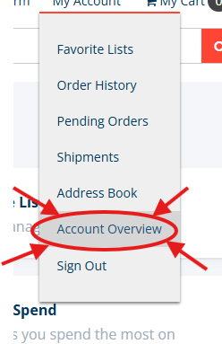
There are a couple groupings of these information pages. These include the following:
- Products
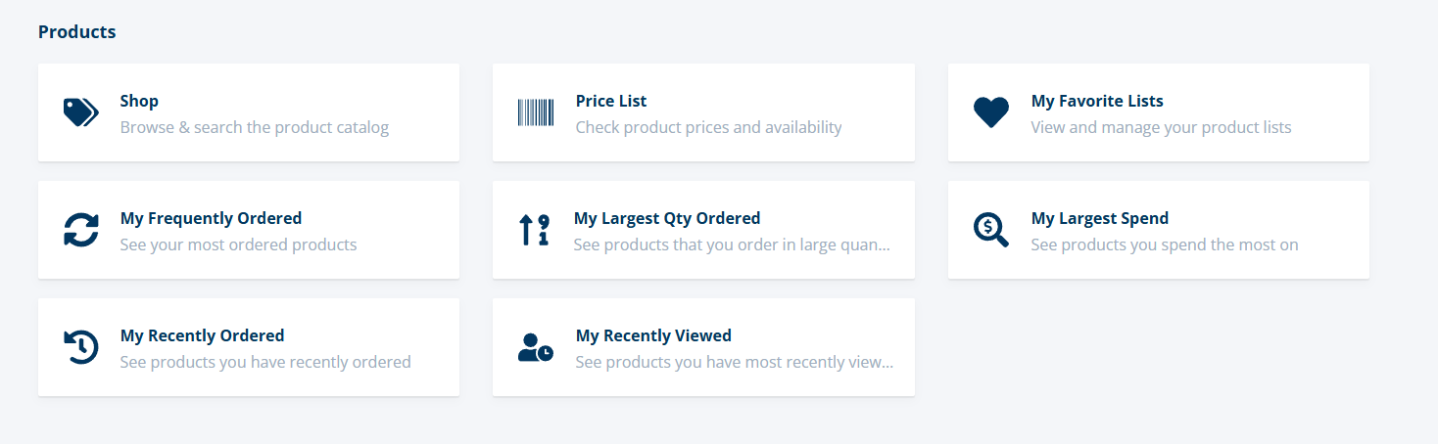
- Ordering
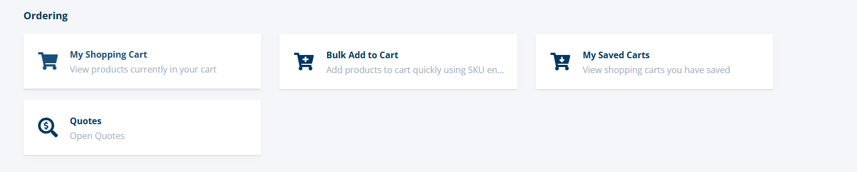
- Orders & Shipments
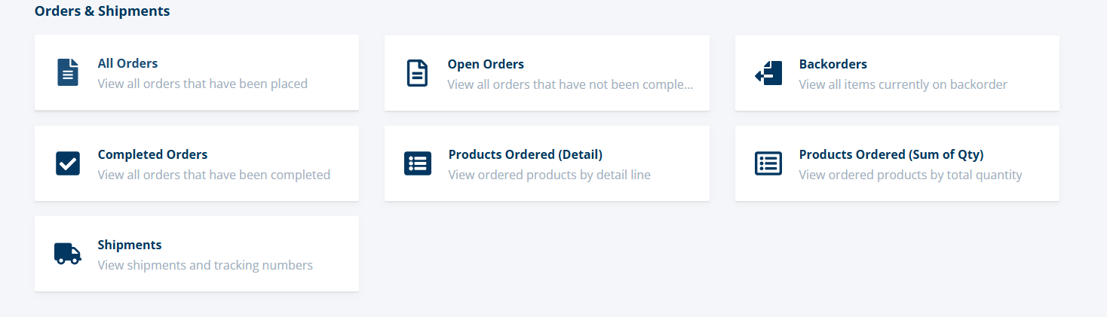
- Invoices
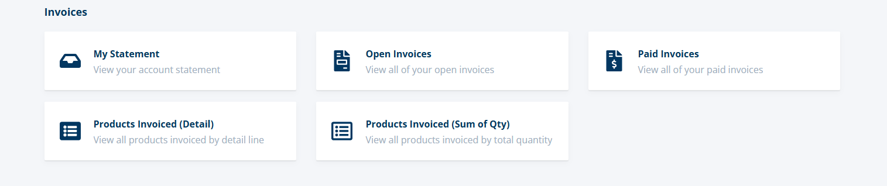
- Payments & Credits
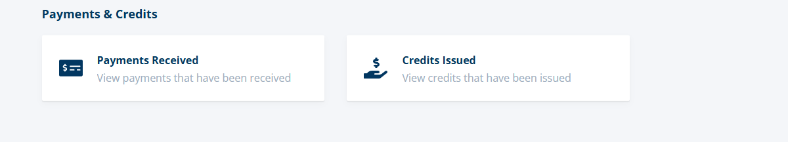
- Support / Help
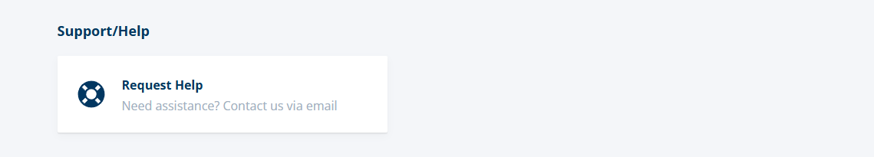
- My account
